**Expressive Self Portrait!**

Identity and Emotion in Art

Course: Studio Art II

Grade Level: 9-12

Mrs. Kostich



Assignment:

Create a dynamic SELF PORTRAIT that expresses a mood and a sense of personality and individuality!

Objectives:

Students will:

1. Explore their personal interests in style
2. Explore a variety of concepts, techniques, and media
3. Experiment with new ideas, find multiple solutions to encountered problems
4. Actively participate in and respond to formal/informal critiques/self assessments
5. Demonstrate an understanding of the Elements of Principles of Art and Design
6. Use the creative process described in the *GDRSD Learning Expectations*
7. Create a self-portrait that expresses personal identity and mood

**Part I: WHO ARE YOU??**

Discovering your Identity

Your answers from the following questions and activities will help you to think about your personality, your interests, your goals, and who you are as a person.

1. **Answer these questions in your sketchbook**. (Do not have to be complete sentences)
2. What are 5 words that you would use to describe yourself?
3. What are 5 words that other people would use to describe you?
4. What are all your favorites? (Colors, animal, ice cream flavor, subject in school, book, movie, artist, music, etc.)
5. What are your favorite hobbies & extracurricular activities? What do you love to do? Any talents or special skills?
6. What are 5 locations that come to mind? (Where are places you go to often? Where are places that make you feel happy or safe? Where are places you would like to go to someday?)
7. What are the 3 moods/emotions you’ve felt recently? (Think about things that have happened over the past week or month. How did you feel then? How do you feel now?)
8. What are 3 major experiences that have impacted your life? (These can be either positive or negative experiences)
9. Which 3 people are the most important to you?
10. Where does your family come from? And/or, where did your ancestors come from? (If you’re not sure, see if you can find out, or skip this question)
11. What are 3 small goals that you have for yourself? What is 1 major goal that you have?

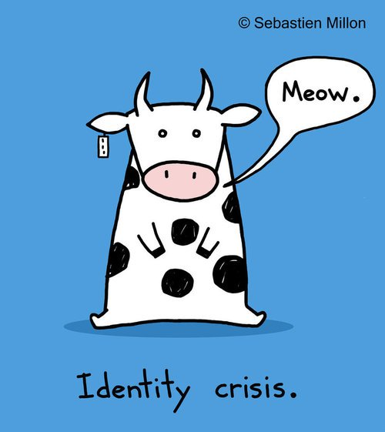

1. **Create an Identity Web.**
2. Start with the word “Identity” in the middle.
3. Branch out to at least 5 major, general interests, or other things that are important to you (Examples: Sports, Animals, Art, Singing, Food, Family, etc.)
4. Then, branch your general interests to more specific interests. **Get as specific as possible!!!!**

Examples:

* 1. Sports 🡪 Basketball, football, baseball
  2. Animals 🡪 Tigers, Dogs (🡪 Golden Retrievers, German Shepherds), Bears
  3. Art 🡪 Drawing, painting (🡪 Acrylic, Oils), artists (van Gogh, Dali, Banksy)

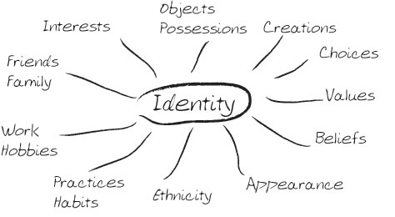

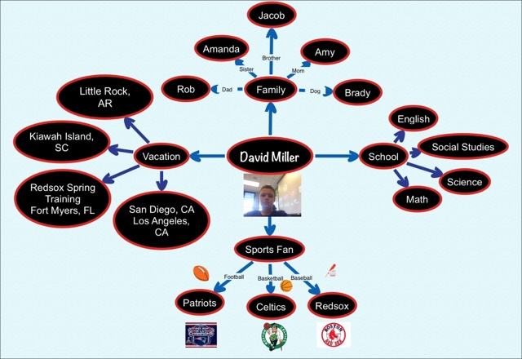

Identity

**Part II: WHAT ARE YOU DOING?!**

Planning your Project

1. **REFERENCE IMAGES**
2. **Take at least 5 selfies**, using the most important aspects of who you are. (If you are not able to do this, find at least 3-5 pictures of yourself that you like.)
   1. When you are taking your selfies, don’t forget about the **Rules of Composition** (Rule of Thirds, Avoid Tangents, Dynamic Angles)
3. **Choose your best** selfies, and find other pictures of yourself that you like. Then, bring the following on _____________________________:
   1. **Digital files of these photos** on your phone, in color (If this is not possible, email them to yourself, or please let me know asap)
   2. **Printed images** of these photos, either in black and white or color (if this is not possible at home, print them at school, or please let me know asap)
4. **SKETCHES**
   1. 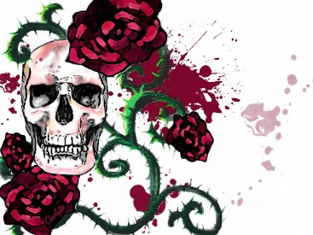Create **5 thumbnail sketches** for the composition of your final piece. These can be in your sketchbook or on the sketch guide (attached).
      1. **CONCEPT:** Create **original, interesting,** and **dynamic** designs. Avoid cliché ideas and symbols (Example of cliché: Bleeding skull with a roses and swords coming out of it)
      2. **DESIGN & COMPOSITION:** Use what you know about the **Elements and Principles** and the **Rules of Composition** (Rule of Thirds, Avoiding Tangents, Dynamic Angles). Deviate away from the traditional portrait (centered & straight on, also known as the “floating head”). Mix it up!
      3. **MOOD:** Choose a mood to be reflected in your work
         1. Refer to your identity questions from Part I to help you decide which mood to choose (Examples: Love, Anger, Envy, Disappointment, Cheerful, Peaceful)
         2. Choose colors, clothes, objects, and themes that are unique to the mood you are portraying.
      4. **IDENTITY:** Incorporate at least **three aspects of your identity**. This piece should represent who you are.
      5. **LIKENESS:** Your face should appear somewhere in your design.
      6. ****Consider the following while drawing sketches:
         1. Amount of body to show
         2. View
         3. Angle
         4. Composition
         5. Costume
         6. Props
         7. Lighting
         8. Expressive quality
      7. Ask yourself these questions while drawing your final sketches:
         1. What perspective or view should the subject be in to best display your mood?
         2. Which elements and principles (line, shape, color, value, texture, space, movement, variety, contrast, unity, balance, emphasis, repetition, scale/proportion) have you used to show your mood?
         3. What type of lines would represent the mood best? (Thick/thin, feminine/masculine, horizontal/vertical, etc.)
         4. What color/colors represent your mood effectively?
         5. How is my portrait creative and inventive?



**Part III: CREATE!**

Making your Self-Portrait



1. **Complete a Final Self Portrait**. Due Date: ________________
   1. Choose your strongest final sketch.
   2. Choose any medium!
   3. Complete a piece with the following dimensions: ______” x ______”
   4. Incorporate the following:
      1. At least **three aspects of your identity**
      2. A particular **mood or feeling**
      3. Personal **likeness**
      4. Unique **concept**
      5. Dynamic **composition**
2. **Assessment:** Midpoint Critiques & Final Critiques
   1. Midpoint Critique (1 week before due date: ___________________________)
      1. Talk about & make judgments about your own work
      2. Talk about & make judgments about your peers’ work
      3. Offer useful, constructive, and thoughtful feedback.
      4. Fill out “Peer Review” sheet, attached
   2. Final Critique (Due date: _________________________________)
      1. Talk about & make judgments about your own work
      2. Talk about & make judgments about your peers’ work
      3. Offer useful, constructive, and thoughtful feedback.
      4. Complete a Critique Sheet

Purpose of this Assignment:

In this project, students explore their personal interest in style and a variety of concepts, techniques, and media to develop a self portrait that expresses identity and mood. Students are asked to demonstrate the following skills in the project:

1. Review systems of visualizing information and depicting space and volume, for example, scale and vanishing point, linear, atmospheric, and isometric perspective; and create works using these systems.
2. Create artwork that demonstrates facility in selective use of elements and principles of design to establish a personal style.
3. Create representational 2D artwork from observation and from memory that convincingly portrays 3D space and the objects and people within that space.
4. Demonstrate the ability to portray emotions through the rendering of physical characteristics in 2D and 3D work.
5. Demonstrate the ability to develop an idea through multiple stages, responding to criticism and self-assessment.
6. Critique their own work and the work of peers.

Students will also incorporate the following **GDRHS Learning Expectations:**

1. **Demonstrate Intellectual Curiosity:** Explore topics independently, show evidence of previous learning, and apply concepts learned within or outside the school community.
2. **Engage in Critical and Creative Thinking:**
   1. Investigate a wide range of sources
   2. Willingly changing perspective, direction, or focus when new discoveries warrant change
   3. Consider multiple perspectives to define a problem
   4. Generate ideas by incorporating the following:
      1. Apply a wide range of idea creation techniques such as brainstorming, innovating, imagining, synthesizing, or changing perspective
      2. Work flexibly to create new and worthwhile ideas (both incremental and radical concepts)
      3. Actively respond to criticism and incorporate feedback into revision of work
      4. Experiment to push ideas and solutions to a new level and be willing to accept setbacks in the pursuit of success
      5. Revise and refine until your work is completed with excellence

Sketch Guide

Complete at least 5 sketches.

**Expressive Self Portrait Midpoint: Peer Review** Name: ____________________________

Mrs. Kostich Date: _____________________________

**Elements of Art:** Line, Shape, Form, Value, Space, Color, Texture

**Principles of Design:** Unity & Harmony, Rhythm, Repetition & Pattern, Balance, Emphasis & Focal Point, Scale & Proportion, Movement, Variety & Contrast

**Composition Guidelines:** Rule of Thirds, Avoiding Tangents, Dynamic Angles, Elements & Principles

**Write the answers the following questions. Describe in detail.**

1. What did your group members say about your piece? (At least one comment per group member)
2. What are three things that you like about your piece, or what aspects of your piece do you think are the most successful? Please be specific.
3. **Essential Question:** How have you illustrated your **individuality/personality** and your chosen **mood/emotion**?

Please be as specific as possible and be sure to answer both questions.

If your piece does not successfully show individuality or mood/emotion, write “see below” in the space provided. Then, in Question #4, explain in detail how you plan to meet these goals.

1. What are your three next steps to complete your expressive self portrait?

**When you are critiquing the work of others:**

Ask yourself the following questions and use them to make judgments and comments about someone’s work. When commenting, try to use the Elements, Principles, Guidelines, and Key Characteristics (listed above) as much as possible.

1. What is one thing that you like about the piece and why?
2. What is one thing that makes this piece successful and why?
3. What is one thing you might change or do differently and why? How would you do it?
4. What is one question you have about the piece?
5. Where does your eye go to first? Where is the focal point or emphasis of the piece?
6. What is the artist’s message? What is the artist trying to express?

Tips to Remember:

1. **Elaborate** as much as possible.

*No:* I like the colors.

*Yes:* I like the warm colors you used because they give the feeling of a bright, sunny day.

1. Don’t use “I don’t like” when making a comment. Try to make a negative comment as **objective** as possible.

*No:* “I don’t like the textures you put in the water.”

*Yes:* “The textures in the water seem a little distracting. Maybe you could use smoother textures instead to bring the viewer’s attention back to the boat.”

1. When possible, try to finish your comment on a **positive note**. (This is not always necessary.)

*Example:* “I think you could push the dark values in the trunk of the tree a little more, but you did a really great job with the value contrast in the leaves.”

1. **Participate** with confidence and don’t be afraid to speak up. Not only is participation part of your grade, but your comments are extremely helpful to the group and to the artist whose work you are critiquing.
2. **Project** your voice so that everyone can hear you. Sit up straight and talk directly to the group and to the artist in particular. What you have to say is important and helpful, especially to the artist whose work you are critiquing, so make sure you are heard.

**When others are critiquing your work:**

Tips to Remember:

1. **Improve:** Critiques are meant to help you improve your artwork as well as your ability to receive criticism. No comments made during critique are meant to be personal: use these comments to your advantage to make a good piece even better.
2. **Make Choices:** Ultimately, you are the boss of your own artwork. Many suggestions will be made about your piece, but you do not have to use them all. Rather than arguing or defending your work, use your own judgment to decide which suggestions would be best to use and which ones you don’t need.
3. **Listen:** Rather than arguing with a commenter or defending your artwork, simply listen to the suggestions being made and take them as they are. Again, you have the final say in which suggestions you take.

**When you are talking about your own work:**

Ask yourself the following questions:

1. What do you feel is most successful about your piece and why? (Or what do you like most about your piece?)
2. What is something you struggled with while working on this piece? How did you overcome this challenge?
3. What would you change about your piece to make it more successful? How would you do this?
4. What is one question you have for the group? What would you like more feedback on?

**Critique Sheet** Name: ____________________________

Mrs. Kostich Date: _____________________________

Project

_________________________________

Key Characteristics:



**Elements of Art:** Line, Shape, Form, Value, Space, Color, Texture

**Principles of Design:** Unity & Harmony, Rhythm, Repetition & Pattern, Balance, Emphasis & Focal Point, Scale & Proportion, Movement, Variety & Contrast

**Composition Guidelines:** Rule of Thirds, Avoiding Tangents, Dynamic Angles, Elements & Principles

**Write the answers the following questions. Describe in detail.**

1. What are three things that people said about your piece?
2. If you are still working on this piece, or if you were to go back and make changes, what would your three next

steps be?



1. What did you like most about this project, and is there anything you would change about the assignment itself or the way it was presented?

Self Portrait: Self Evaluation & Reflection Name: ___________________________

Studio Art II

Mrs. Kostich Date: ____________________________

**Elements of Art:** Line, Shape, Space, Color, Form, Value, Texture

**Principles of Design:** Balance, Unity & Harmony, Pattern, Rhythm, & Repetition, Variety & Contrast, Scale & Proportion, Movement, Emphasis & Focal Point

1. What mood or emotion did you choose for this project?
2. How did you convey this mood or emotion in your piece?
3. How does your portrait illustrate your individuality or personality?
4. What is the most successful part of your piece, and why?
5. What is one thing that you struggled with while making your piece? How did you overcome this?
6. Choose **3 principles of design** that are the most prominent in your piece, and describe how you used them:

|  |  |
| --- | --- |
| Balance |  |
| Unity & Harmony |  |
| Pattern, Rhythm, & Repetition |  |
| Variety & Contrast |  |
| Scale & Proportion |  |
| Movement |  |
| Emphasis & Focal Point |  |

|  |  |  |  |  |
| --- | --- | --- | --- | --- |
| **Rubric: Expressive Self Portrait**  Studio Art II  Mrs. Kostich | | Totals | | Name: ________________  Project Date: ___________ |
| Student Score | Teacher Score |
| **Sketches; Critical & Creative Thinking: Envision, Stretch Explore**   * Wide range of idea creation techniques: Brainstorming, innovating and imagining, synthesizing or changing perspective * Push ideas to new level by willingly changing perspective, direction, or focus when new discoveries warrant a change * Sophisticated composition achieved using the Elements and Principles of Art Design, Rules of Composition | | ___  10 | ___  10 | Comments |
| **Composition & Design: Develop Craft**   * Use of **Elements & Principles** and **Rules of Composition** (Rule of Thirds, Dynamic Angles, Avoiding Tangents) to create an interesting, dynamic, and unique composition | | ___  10 | ___  10 |
| **Elements and Principles: Develop Craft, Understand Art World, E&P**   * Use of Elements and Principles of Art and Design in order to express emotion and identity * Accurate use of proportion, space, light source, color and color temperature, perspective, value/color contrast when applicable | | ___  10 | ___  10 |
| **Creation of Mood/Emotion: Express**   * Dramatically incorporate elements and principles of art and design to create a mood in your work (Color, value, contrast, balance, unity, emphasis, etc.) * Portray emotions through rendering of physical characteristics | | ___  10 | ___  10 |
| **Likeness & Proportion: Observe and Develop Craft**   * Portrait has accurate resemblance to artist * Accurate proportions, individual characteristics | | ___  10 | ___  10 |
| **Creativity & Personal Expression: Express**   * Strong evidence of personal meaning, reference, and input * Demonstrate engagement with subject, concept/stylistic issues, materials, techniques, & media | | ___  10 | ___  10 |
| **Concept & Creativity: Express**   * Interesting, dynamic, unique concept: cliché ideas avoided | | ___  10 | ___  10 |
| **Execution: Materials & Techniques: Observe and Develop Craft**   * Exceptional use of chosen medium * Work is revised & refined with exceptional effort | | ___  10 | ___  10 |
| **Participation: Process: Engage and Persist, Stretch and Explore**   * Focus and persevere, Work to full potential * Generate solutions to encountered problems, learn from mistakes * Actively participate in class critiques * Respect & Safety of materials (Clean area thoroughly, use materials safely) * Complete and hand in work on time * Discuss own work & process; open to suggestions and feedback, receptive to criticism and new ideas * Evidence of time management | | ___  10 | ___  10 |
| **Participation: Critique: Engage and Persist, Reflect**   * Actively participate in peer review and discussion * Think, talk, and make judgments about own & others’ work * Acknowledge the strengths and weaknesses within a piece * Offer constructive criticism & possible next steps * Speak with confidence, knowledge, & articulation * Reflect & complete a peer review worksheet | | ___  10 | ___  10 |
|  | Points Earned |  |  |  |
| Total Points | 100 | 100 |