Sketchbook Assignments Name: _______________________________
Due Monday
Studio I Date: ________________________________
Mrs. Kostich

- Complete a 90% right brain, observational contour drawing of a shoe in your sketchbook. It can be any kind of shoe (except the one in the example!)

- Take your time, and include as much detail as possible.

- Draw lightly.

- Use line weight to show value and physical weight, but don’t overdo it

- Show your understanding of all the concepts we’ve gone over so far – right brain drawing, implied line, ellipses, cross contour, texture, form. Remember, showing understanding means that you are using what you know about these concepts to create a strong contour drawing.

- Ink the drawing (draw over your lines) with an extra fine tip Sharpie. Be careful – the ink might bleed onto the next page. When you’re done, erase any extra pencil lines that you see.

- Label “Contour Drawing Homework” and date it.
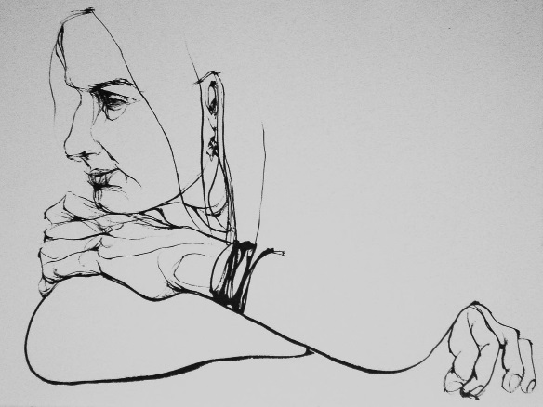
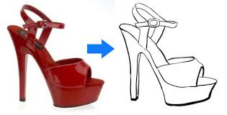

- Do a sketchbook check. I will be collecting sketchbooks on Monday.

- Label every page/drawing that you have. (For example, at the top of a page of ellipse drawings, write “ellipse.”)

- Staple all notes and loose papers into your sketchbook. (Please staple one paper onto each page instead of stapling a stack of papers.)

- If you weren’t feeling sure about a particular type of drawing (ellipse or cross-contour), try drawing another one at home. You will be graded on your best drawing AND your level of improvement in each section.

- If you were absent, make up any missing work.

- If you are missing any assignments so far, make them up.

