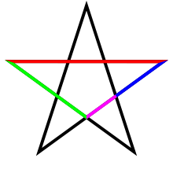The Golden Ratio / Fibonacci Sequence

Studio Art: Mrs. Kostich

Golden Mean, Phi, Divine Proportion, Fibonacci Sequence, Golden Rectangle/Triangle

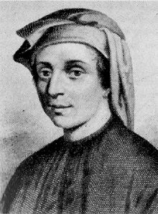1.6180339887…

About 5:8 or 1.618

* The study of the golden ratio dates back at least 2,400 B.C.E. to Ancient Greece.
* Fibonacci, or Leonardo da Pisa (1175-1250 CE): An Italian mathematician who published the number sequence first discovered by mathematicians in India.

The Fibonacci Sequence

Each number is the sum of the previous two numbers starting with 0 and 1.

**0, 1, 1, 2, 3, 5, 8, 13, 21, 34, 55, 89, 144, 233, 377, 610, 987………**

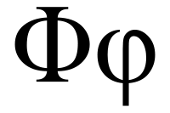

Fibonacci

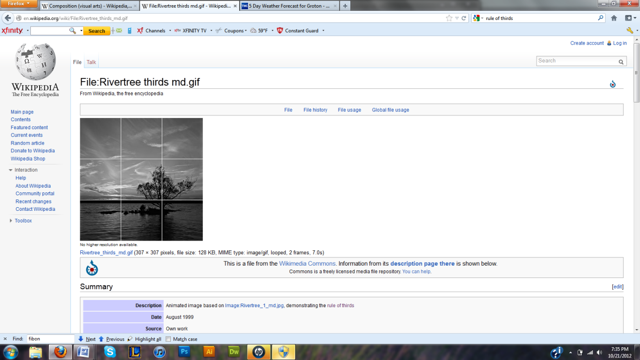The higher the numbers in the sequence, the closer they get to the golden ratio: About 1:1.618.

The Rule of Thirds in visual composition is a simplification of this ratio.

The Rule of Thirds 🡪

Phi: The Greek symbol for the Golden Ratio

Aside from its occurrence in mathematics and the shape of the pentagon, the golden ratio is important to historians, biologists, scientists, mystics, architects, musicians, artists.

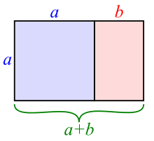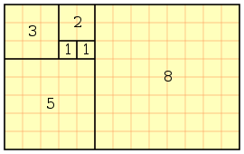

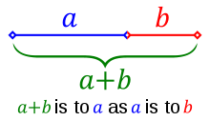

1.61

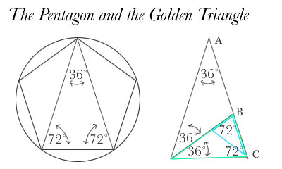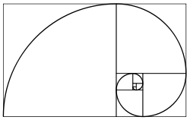

The Fibonacci Sequence

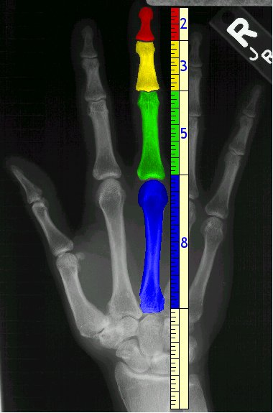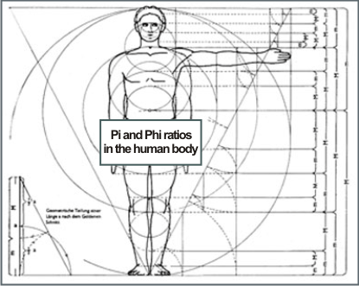

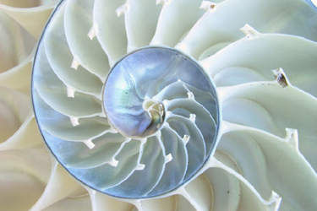

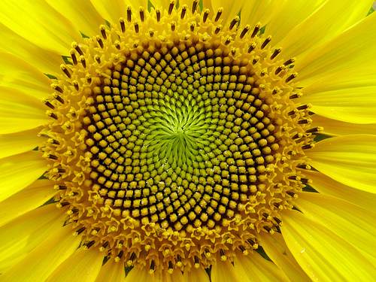

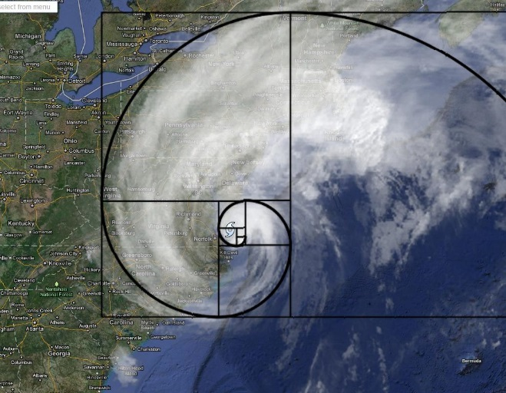



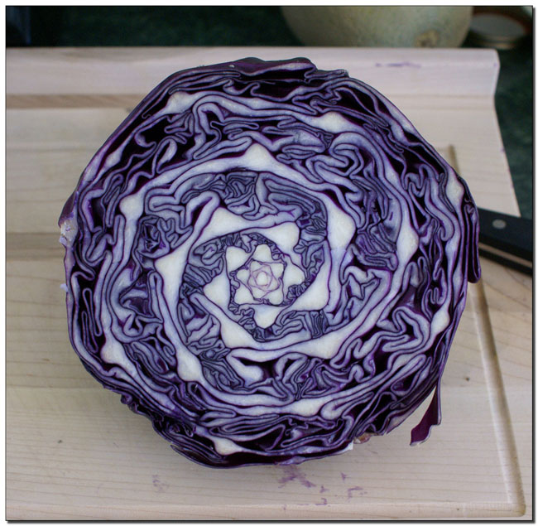



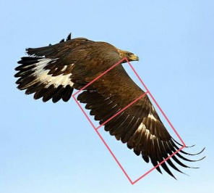

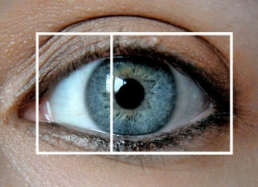

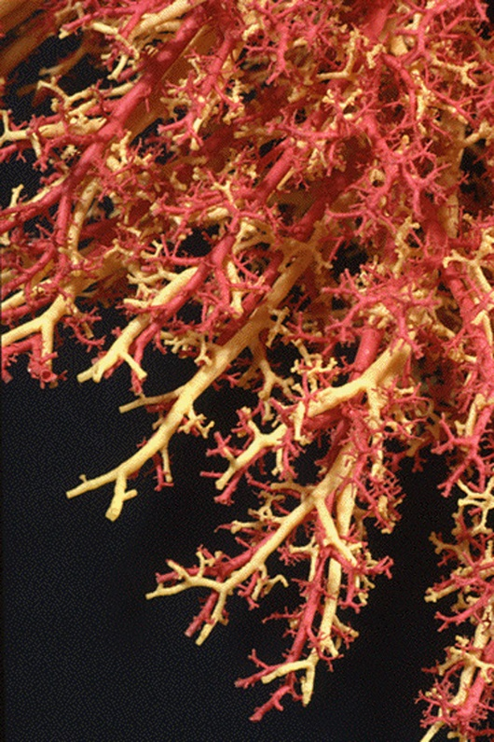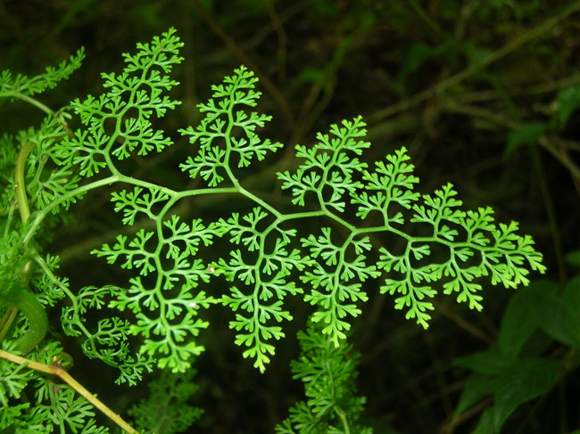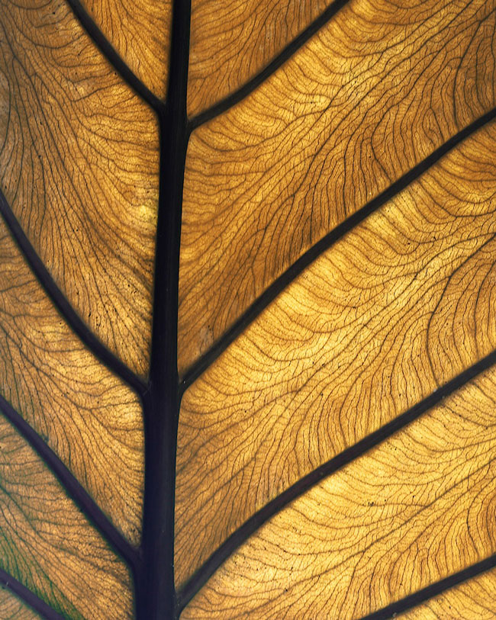

The Golden Ratio in History: Architecture and Art

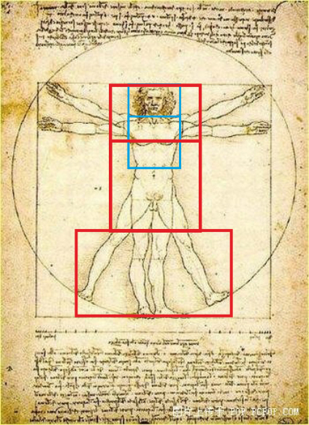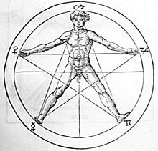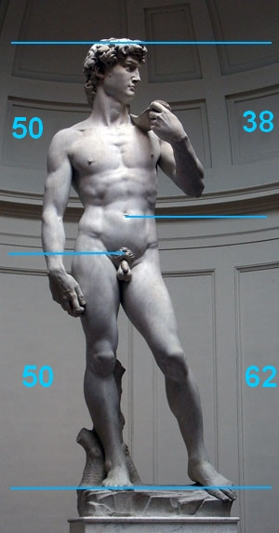

*Vitruvian Man*, Leonardo da Vinci, 1490

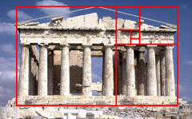

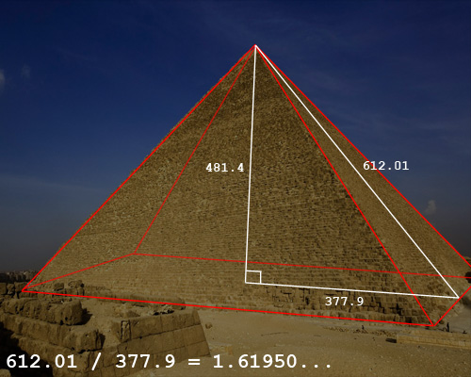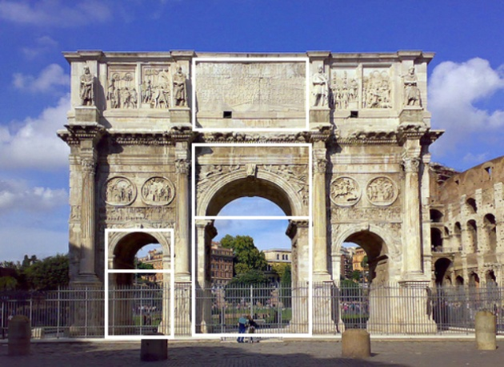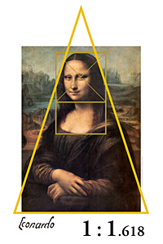

The Great Pyramid in Giza, Egypt, 2540 BCE

The Arch of Constantine in Rome, Italy, 325 CE

The Parthenon in Athens, Greece. 432 BCE

*David*, Michelangelo, 1504

*Mona Lisa*, Leonardo da Vinci, 1506