Expressive Space Animal Name: _________________________
Studio Art I
Mrs. Kostich Date: __________________________

Assignment
You will be creating a piece that explores Expressive Line (line that shows emotion/feeling) and the relationship between Positive & Negative Space.

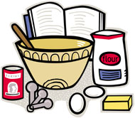
Elements
The Elements of Art that we will focus on are Line and Space.
The piece will contain an Expressive Line design that expresses the mood, emotion, or feeling of your choice through line variation and line weight.
Your animal will act as the Positive Space of your design on one side and the Negative Space of your design on the other.

Principles
The Principles of Design that we will focus on are Balance and Unity/Harmony.
Your Positive & Negative Space will have Symmetrical Balance (both sides look the same).
While your Expressive Line design will have Asymmetrical Balance (not the same on both sides), it will still have Unity and Harmony, meaning that both sides of your design will appear similar and connected.

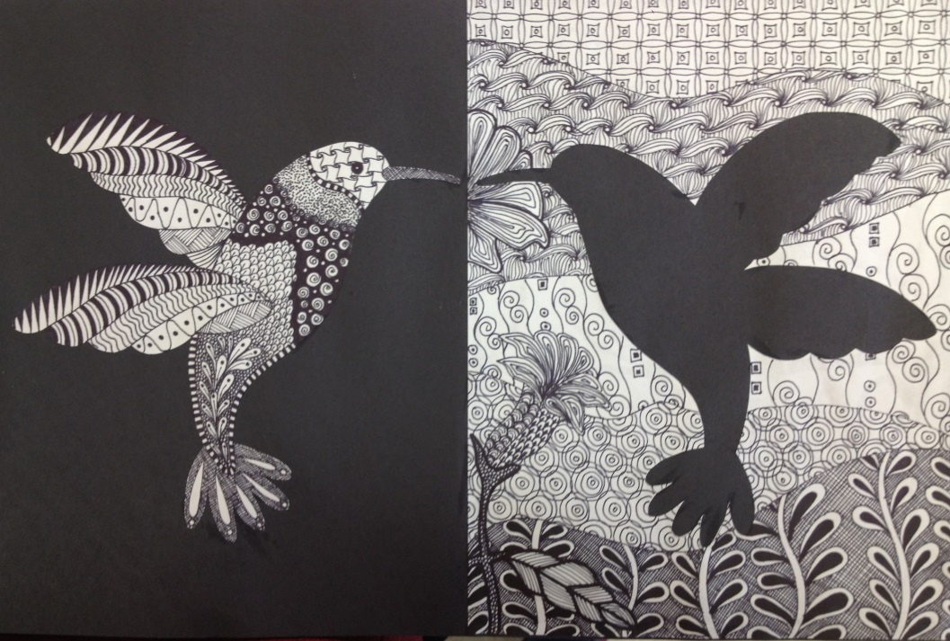

Instructions
- Choose an animal.

- Draw your animal onto your vertical white piece of paper (6x9”). Your animal should be touching one of the long edges. You may use the rubbing technique to trace your animal.

- Use scissors (or an X-Acto knife) to carefully cut along the contour of your animal. There should be no paper scraps – you will use BOTH the positive and negative spaces of your animal.

Safety Tip: If you are using an X-Acto knife, only use one that has a cap.

- Use a glue stick to glue the white paper (negative space) onto one side of your black paper. The corners should match perfectly, and your animal should be toward the inside of your paper.
Glue Tip: Do not use your glue stick on the black paper. It will be shiny when it dries, making your paper look dirty.
- Flip your animal (positive space) onto the other side of the black paper so that it is an exact mirror image to its negative space. Glue your animal down to the paper.

- Use your chosen emotion to create an intricate design that depicts this emotion. Things to remember when you are creating your design:

  - Use what you know about facial expressions and body language to contribute to your design
  - Incorporate line variation (different line weights, solid shapes, and details)
  - Make your design go off the edges of the page (implied line)
  - Use of symbols should be minimal

- When you are finished, answer the questions and follow the instructions on the back of the rubric.

- Complete the rubric. Hold on to this for now.

- - - - - - - - - - - - - - - - - - - - - - - - - - - - - - - - - - - - - - - - - - - - - - - - - - - - - - - - - - - - - - - - - - - - - - - - - - - - - - - -

